|  |
| --- |
| GOVTecthon |
| Open Innovation Challenge 2.0 |

31:12:2021

# Phc management System

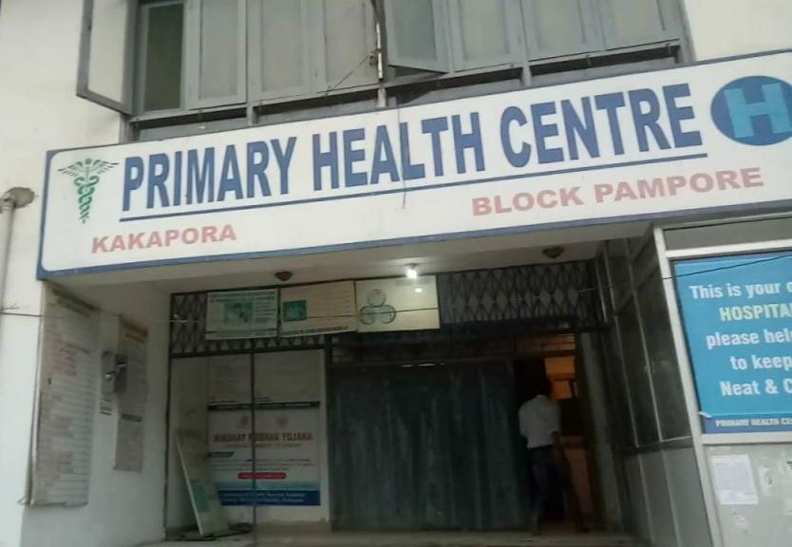The purpose of the project entitled as “PHC MANAGEMENT SYSTEM” is to computerize the Front Office Management of Hospital to develop software which is user friendly simple, fast, and cost – effective. It deals with the collection of patient’s information, diagnosis details, etc. Traditionally, it was done manually. The main function of the system is register and store patient details and doctor details and retrieve these details as and when required, and also to manipulate these details meaningfully System input contains patient details, diagnosis details, while system output is to get these details on to the screen. The PHC Management System can be entered using a username and password. It is accessible either by an administrator or receptionist. Only they can add data into the database. The data can be retrieved easily.  The data are well protected for personal use and makes the data processing very fast.

## INDEX

1.Introduction

2.Management:

2.1.Login

2.1.1.Doctor team

2.1.2.IT TEAM

2.1.3Management

2.2.IT

2.2.1.Add/ update doctor, nurse status

2.2.2.ID Updation

2.2.3.Recent Events

2.2.4.User stock

2.2.5.Alerts

2.2.5.1.Pre registered appointments

2.2.5.2.Follow up

2.2.5.3.Medical history based alerts

2.3.Medical team

2.3.1.Display medical history

2.3.2.Visits

2.3.3.Upload present prescription

2.3.4.Update medical history

2.4.Management

2.4.1Token system

2.4.1.1.User name

2.4.1.2.Date

2.4.1.3.Time

2.4.1.4.Doctor assigned

2.4.2.Stock update

2.4.3.create tokens

2.4.4.ID Creation

2.4.5.Request for Receive update

1.Introduction

The project Primary Health Center Management system includes registration of patients, storing their details into the system, and also computerized billing in the pharmacy, and labs. The software has the facility to give a unique id for every patient and stores the details of every patient and the staff automatically. It includes a search facility to know the current status of each room. User can search availability of a doctor and the details of a patient using the id.

The PHC Management System can be entered using a username and password. It is accessible either by an administrator or receptionist. Only they can add data into the database. The data can be retrieved easily. The interface is very user-friendly. The data are well protected for personal use and makes the data processing very fast.

PHC Management System is powerful, flexible, and easy to use and is designed and developed to deliver real conceivable benefits to hospitals.

PHC Management System is designed for rural side hospitals, to cover a wide range of hospital administration and management processes. It is an integrated end-to-end Hospital Management System that provides relevant information across the hospital to support effective    decision making for patient care, hospital administration and critical financial accounting, in a seamless flow.

PHC Management System is a software product suite designed to improve the quality and management of hospital management in the areas of clinical process analysis and activity-based costing. Hospital Management System enables you to develop your organization and improve its effectiveness and quality of work. Managing the key processes efficiently is critical to the success of the hospital helps you manage your processes

### Objective:-

1)      Define hospital

2)      Recording information about the Patients that come.

3)      Doctors Availability

4)      Recording information related to diagnosis given to Patients.

5)      Keeping record of the Immunization provided to children/patients.

6)      Keeping information about various diseases and medicines available to cure them.

These are the various jobs that need to be done in a Hospital by the operational staff and Doctors. All these works are done on papers.

2.Management

Hospital management system is a computer system that helps manage the information related to health care and aids in the job completion of health care providers effectively. They manage the data related to all departments of healthcare such as,

Clinical

Laboratory

Inpatient

Outpatient

Materials

Nursing

Pharmaceutical

Pathology etc.

HMS came into the picture of hospital management as early as 1960 and have ever since been evolving and synchronizing with the technologies while modernizing healthcare facilities. In today’s world, the management of healthcare starts from the hands of the patients through their mobile phones and facilitates the needs of the patient.

## 2.1.Login

 A set of credentials used to authenticate a user. Most often, these consist of a [username](https://techterms.com/definition/username) and [password](https://techterms.com/definition/password). However, a login may include other information, such as a PIN number, [passcode](https://techterms.com/definition/passcode), or [passphrase](https://techterms.com/definition/passphrase). Some logins require a [biometric](https://techterms.com/definition/biometrics) identifier, such as a fingerprint or retina scan.

## 2.1.1.Doctors Team

This interactive healthcare dashboard example serves as a doctor’s scorecard to track performance and workload. The end user can click on the picture of the doctor to reveal details of their patient load, demographic distribution, and key performance indicators like average wait time and patient survey results. The interactive map on the left of the dashboard shows the doctors’ specialty, location, patient load and availability, as well as their physical location within the office. Scroll down to interact with this doctor dashboard.

## 2.1.1.IT TEAM

Hospital IT departments have an essential role to play in assisting hospital staff to manage and care for patients. These systems are so essential and ingrained into modern-day hospitals that it can literally be a matter of life or death if they stop working effectively.

This is in addition to the usual tasks an IT department performs such as providing network infrastructure, [IT security](https://www.alert-software.com/blog/managing-cyber-security-crises-with-deskalerts), server maintenance, software deployments and so on.

## 2.2.IT

## 2.2.1.Add/Update Doctors, Nurse Status

Hospital doctors examine patients so that they can diagnose and treat health conditions and diseases. GPs (general practitioners) and other health professionals refer patients to hospital doctors.

A staff nurse is a registered nurse who provides high-quality care to employees of a company, residents of nursing homes, or patients in a hospital. They are responsible for initial patient assessment, monitoring patients' vital signs, and nurturing patients to recovery.

## 2.2.2.ID Updation

With hundreds of patients, doctors, surgeons, staff and visitors walking the halls of hospitals every day, security and identification can quickly become a concern. Hospital ID cards - whether they're for staff, patients, or visitors (or a combination thereof) can help staff organize and secure a large number of people in a busy environment. ID cards for doctors and nurses can be simple [blank ID cards](https://www.alphacard.com/blank-id-cards), or [proximity cards](https://www.alphacard.com/id-card-solutions/alphacard.com/prox-access-control-cards) that allow for access control.

ID cards at hospitals can be used in a variety of ways, and multipurpose ID cards with several features can be a boon for hospital efficiency.

## 2.2.3.Recent Events

Recent Events of a hospital is displayed on home of the PHC management website publish by the IT department of the Hospital, Because of the User experiencing the more detailed news of the current situation of the Hospital.

## 2.2.4.User Stock

Maintain stock database, track **inventory movements**. You can now keep an eye on the inventory levels for Hospitals with great ease with the Inventory Management System. This software notifies the **Clinics, Hospitals,** and **Doctors** about the stock available which helps them reload from time to time thereby allowing doctors to prescribe the patients with the right medicines. This in turn allows a smooth functioning, avoiding clashes and waiting hours.

## 2.2.5.Alerts

## 2.2.5.1.Pre Registered Appointments

Patient pre-registration is a key strategy for improving the on boarding and intake process, which can often get bogged down with complicated data collection and administrative tasks. By collecting patient intake materials ahead of the appointment, pre-registration helps organizations create a higher quality consumer experience and increased patient satisfaction.

The patient registration process is instrumental for giving a good first impression of a healthcare organization. A positive patient experience that starts at the check-in desk can set the tone for the entire care encounter.

## 2.2.5.2.Medical History Based Alerts

Information technology supporting patient self-management has the potential to foster shared accountability for healthcare outcomes by improving patient adherence. There is growing interest in providing alerts and reminders to patients to improve healthcare self-management. This paper describes a literature review of automated alerts and reminders directed to patients, the technology used, and their efficacy.

## 2.3.Medical Team

The healthcare team, regardless of whether you’re treated at a large academic institution or a small, rural private practice, is the group of professionals who contribute to your care and treatment as a patient. Typical members of a healthcare team are a doctor and a registered nurse. In some cases, there might be a Nurse Practitioner instead of or as well as a doctor. In others, physical therapists, occupational therapists, and social workers may be part of the team. Office managers also play an important role in the healthcare team.

**2.3.1.Display Medical History**

Doctors and hospitals use a medical history of a patient to review his/her health history. It’s a very important part of their workflow to ensure they’re providing the best care and treatment. A patient’s medical history may include details about past diseases, illnesses running in the family, previous diagnoses, medical abstract, therapies, allergies, and medication. Yes, this is not the whole picture but with the help of a detailed medical history, doctors can see health patterns of patients over time at a glance.

**2.3.2.Visits**

A doctor's visit, also known as a physician office visit or a consultation, or a ward round in an [inpatient care](https://en.m.wikipedia.org/wiki/Inpatient_care) context, is a meeting between a [patient](https://en.m.wikipedia.org/wiki/Patient) with a [physician](https://en.m.wikipedia.org/wiki/Physician) to get [health](https://en.m.wikipedia.org/wiki/Health) advice or [treatment](https://en.m.wikipedia.org/wiki/Therapy) plan for a [symptom](https://en.m.wikipedia.org/wiki/Symptom) or [condition](https://en.m.wikipedia.org/wiki/Medical_condition), most often at a professional [health facility](https://en.m.wikipedia.org/wiki/Health_facility) such as a [doctor's office](https://en.m.wikipedia.org/wiki/Doctor%27s_office), [clinic](https://en.m.wikipedia.org/wiki/Clinic) or [hospital](https://en.m.wikipedia.org/wiki/Hospital). According to a survey in the [United States](https://en.m.wikipedia.org/wiki/United_States), a physician typically sees between 50 and 100 patients per week, but it may vary with [medical specialty](https://en.m.wikipedia.org/wiki/Specialty_(medicine)), but differs only little by community size such as metropolitan versus rural areas.

**2.3.2.Upload Present Prescription**

Every prescription contains [who prescribed the prescription](https://en.m.wikipedia.org/wiki/Signature), [who the prescription is valid for](https://en.m.wikipedia.org/wiki/Patient), and [what is prescribed](https://en.m.wikipedia.org/wiki/Medical_treatment). Some jurisdictions, drug types or patient groups require additional information as explained below.

**2.3.3.Update Medical History**

A **Client**'s **Medical History** is stored as part of their **Care Documentation** on the **Client**'s profile. Additional fields will be available for US agencies required to submit 485 forms.

To review a **Client**'s **Medical History**, navigate to the **Client** profile and click **Care Documentation**. Select the **Medical History** tab.

From here, you can review, complete, and update the various sections of the**Client**'s**Medical History** (**Current Medical History, Past Medical History, Infectious Diseases**, **Past Surgeries and/or Treatments**, **Recent Hospitalizations**, **Immunization History**, **Allergies**, etc.)

**2.4.Management**

**2.4.1.Token System**

MEDCAL - an OPD Token Calling System is specially designed to bring about order, efficiency and comfort in clinics and hospitals thereby reducing the queue and confusions created while waiting. OPD Token Calling System is primarily controlled by the doctor wherein he/she can control the patients entering the consulting room by selecting a particular token number. Once the patient is inside, yellow light glows in the system and when the doctor selects vacant & next token number, green light glows indicating the consulting room is vacant.

**2.4.2.Stock Update**

Maintain stock database, track **inventory movements**. You can now keep an eye on the inventory levels for Hospitals with great ease with the Inventory Management System. This software notifies the **Clinics, Hospitals,** and **Doctors** about the stock available which helps them reload from time to time thereby allowing doctors to prescribe the patients with the right medicines. This in turn allows a smooth functioning, avoiding clashes and waiting hours.

**2.4.3.Create Tokens**

Our token management systems are simple yet technologically advanced and designed with end-customers in mind. Our Queue management systems are simple in use and help customers to optimize ROI and the service efficiency instead of getting confused with the technical complexity of the system.

Being a prominent token management system development company in Kerala, Kochi, we start our work from basics and understand each of the requirements minutely. Our token management systems or queue management systems are tailored to fit tough customer requirements in their budgets.

**2.4.4.ID Creation**

Hospital ID Badges are crucial for everyone who works in a hospital, including army hospitals, clinics, nursing homes and the emergency room.  Both hospitals and clinics are extremely regulated places, due to the nature of their medical activities. In order to control employees access and to identify their medical staff, hospitals frequently use Hospital ID Cards.  Some common things hospital badges include are name, position at the hospital, address, and degree issue.

It is advised that you purchase a [Lanyard](https://www.idcreator.com/id-card-accessories/lanyards) to perfectly hold and show your Hospital Badge!

For other health related templates, check out [Doctor ID Cards](https://www.idcreator.com/id-card-templates/doctor-id-cards), [Nurse ID Cards](https://www.idcreator.com/id-card-templates/nurse-id-cards), [Paramedic ID Cards](https://www.idcreator.com/id-card-templates/paramedic-id-cards), and [Physician ID Cards](https://www.idcreator.com/id-card-templates/physician-id-cards).

**2.4.5.Request for Receive Updates**

**PHC Management System makes it possible to access all the data related to a patient via a system by the means of a few simple clicks. Information like patient history, current illness, doctors involved, tests reports taken, billing information and many more can be made visible to the user. These data will help to connect the dots about the patient, like specific diagnosis, related treatment, and medication.**